**UML DIAGRAMS**

# **ANALYSIS AND DESIGN**

Workflow Diagram/ Swimlane (Financial Activity of Agricultural Land)

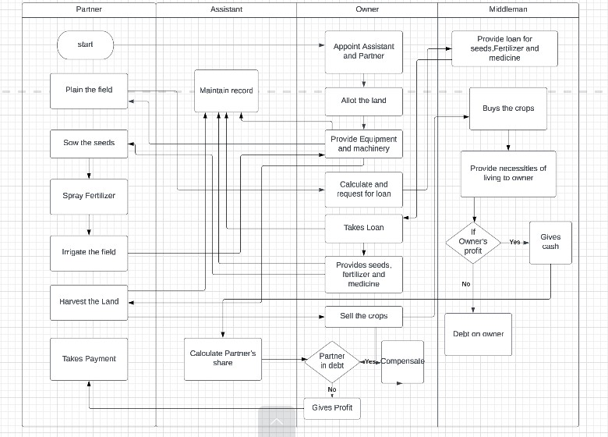

In the above figure first partner and assistant will come to owner for a job than after hiring them owner will allot the land and provide equipment and machinery assistant will record it and partner will plain the field than owner calculates and request for loan. Middleman provides loan owner takes that loan and provide seeds fertilizers and medicines to partner which assistant will maintain in the record and partner will sow the seed, spray fertilizers and irrigate the field than he will again request for machinery which owner will provide him so that he can harvest the land which will be maintained in record by assistant and owner will sell the crops and middleman will buy the crops and provide necessities of living to owner than he will take decision that owner is in deficit or profit if he is in profit than he will give cash from which assistant will calculate partner’s share and owner will take decision that if partner is in deficit than compensate otherwise gives profit to partner.

**Context diagram:**

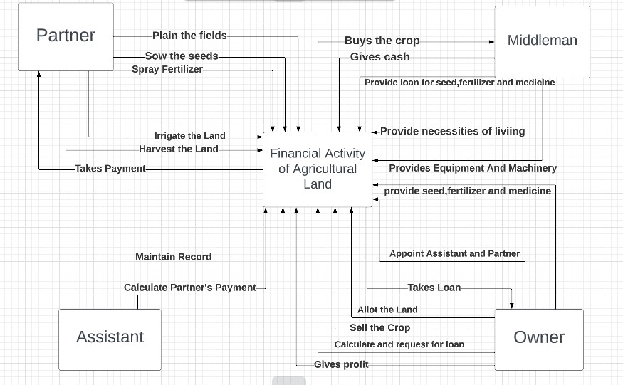

In the above figure first partner and assistant will come to owner for a job than after hiring them owner will allot the land and provide equipment and machinery assistant will record it and partner will plain the field than owner calculates and request for loan. Middleman provides loan owner takes that loan and provide seeds fertilizers and medicines to partner which assistant will maintain in the record and partner will sow the seed, spray fertilizers and irrigate the field than he will again request for machinery which owner will provide him so that he can harvest the land which will be maintained in record by assistant and owner will sell the crops and middleman will buy the crops and provide necessities of living to owner than he will take decision that owner is in deficit or profit if he is in profit than he will give cash from which assistant will calculate partner’s share and owner will take decision that if partner is in deficit than compensate otherwise gives profit to partner.

**Usecase diagram:**

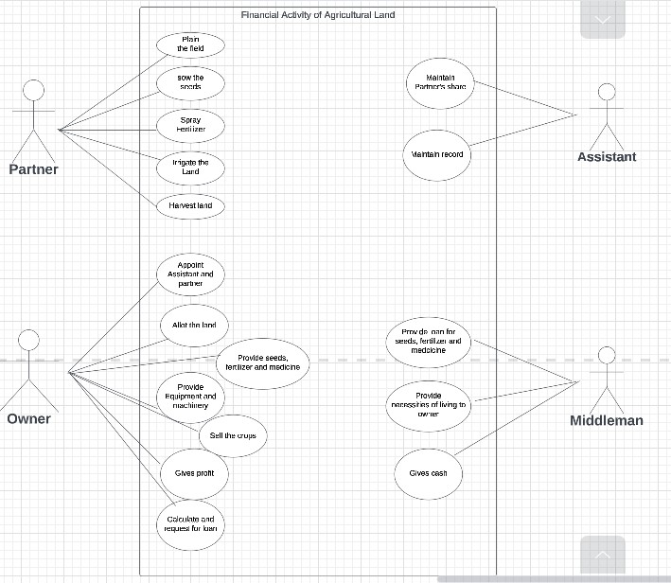

The above figure represents the initiation of actors, where middleman is providing loan, necessities and cash to owner. Assistant is maintaining record and Calculates partner’s share. Whereas partner plains the field, sow the seeds, spray fertilizers, irrigate the land and harvest the land. Owner appoints assistant and partner, allot the land, calculates and requests for loan, provide machinery and seeds, sell the crops and gives profit.

**Object diagram**

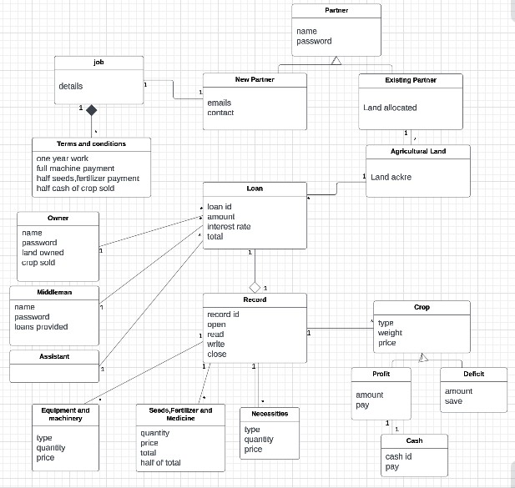

**Sequence diagram**

Appoint Partner

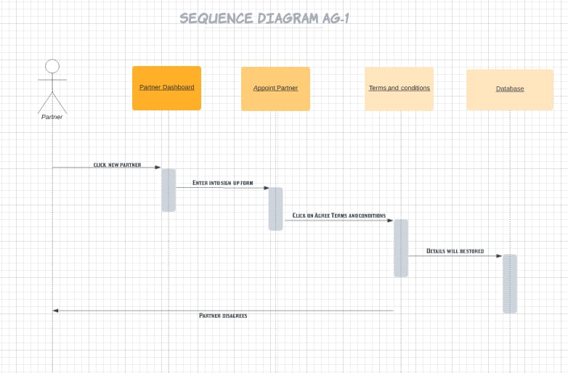

Allot the Land

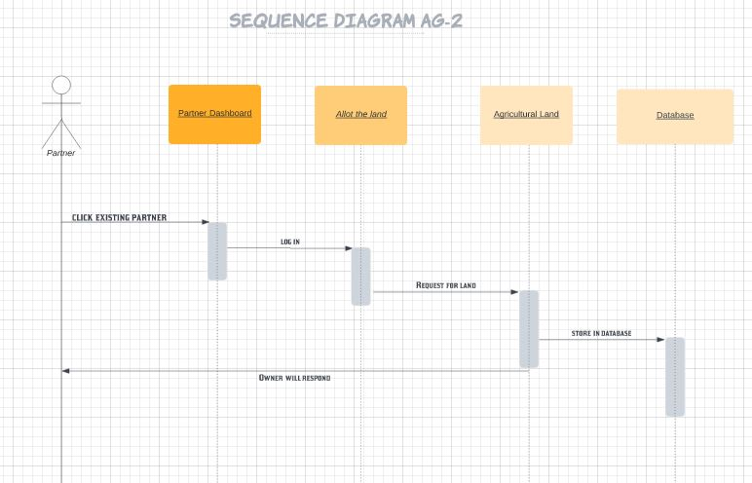

Provide Equipment and Machinery

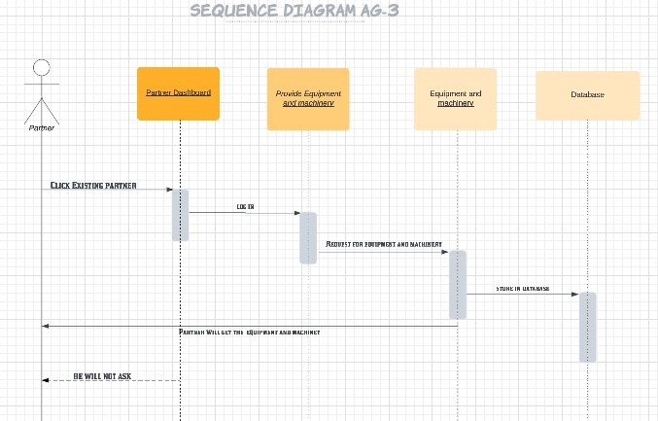

Calculate and request for loan

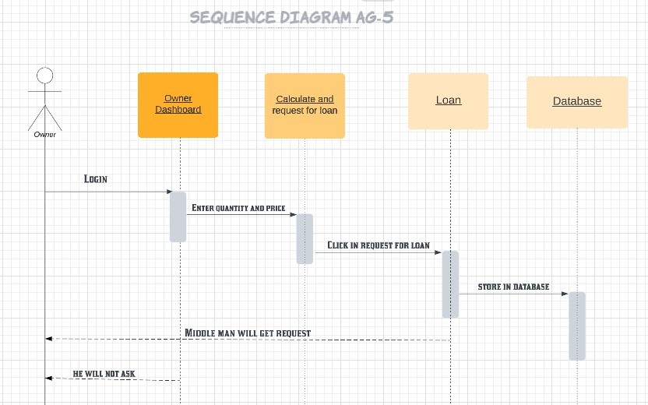

Provide seeds, fertilizers and medicines

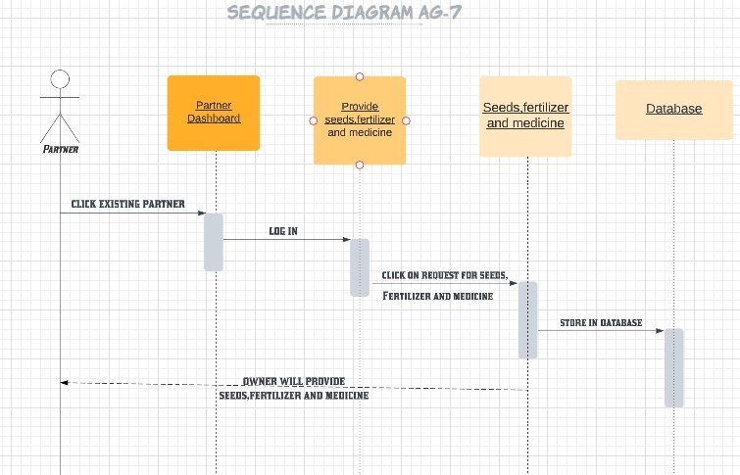

Provide Necessities of living to owner

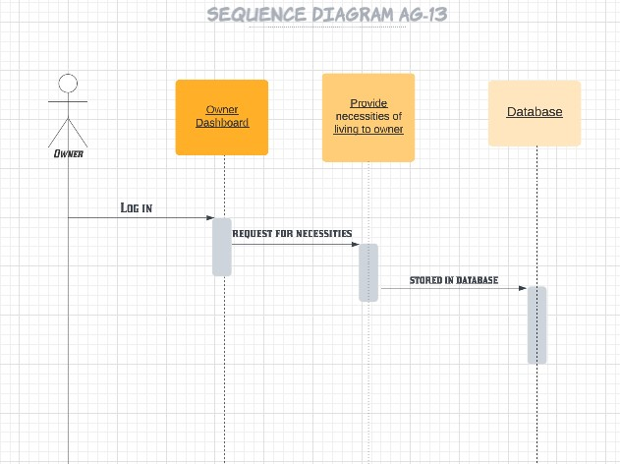

Gives Cash

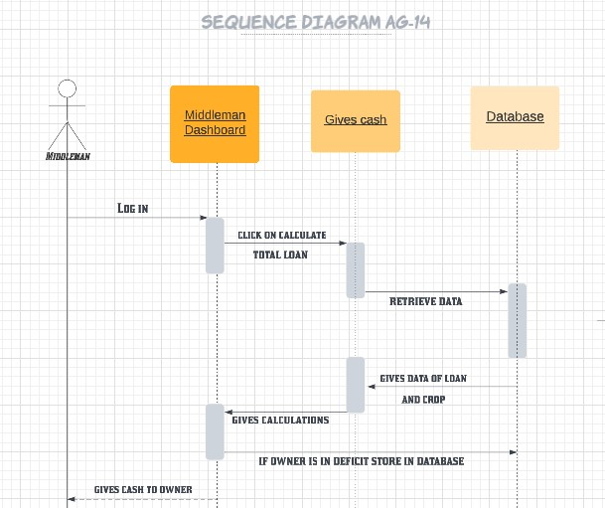

Maintains Record

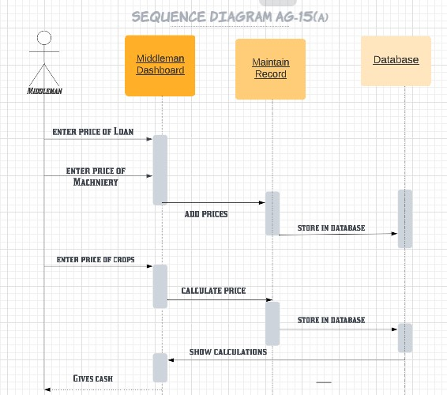

Maintains Record

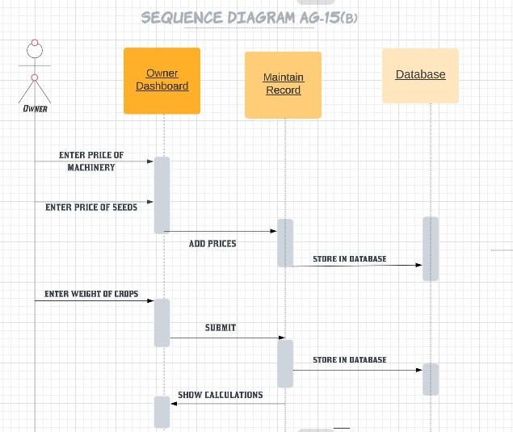

Calculate Partner’s Share

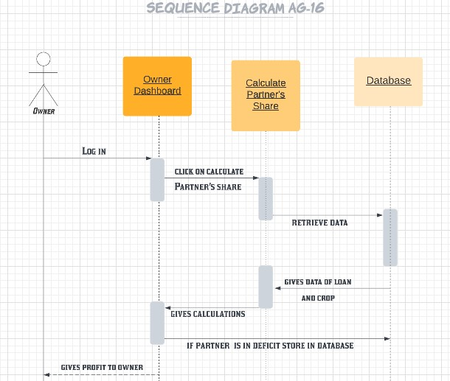

**Class Diagram**

